**Three-Phase Inverter (SPWM Modulation)**

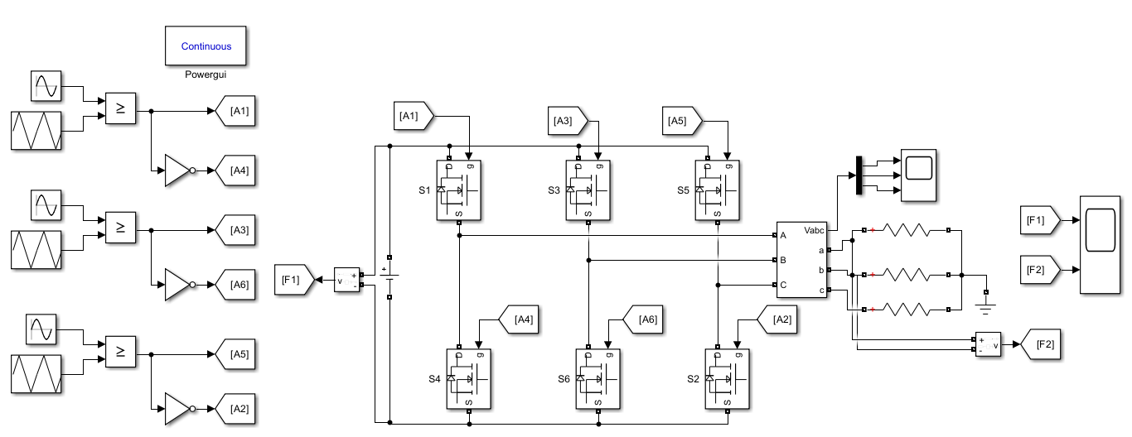

**Fig. Block Diagram of Three-Phase Inverter (SPWM Modulation)**





**Fig. Characteristics of Three-Phase Inverter (SPWM Modulation)**

**Multilevel Inverter**

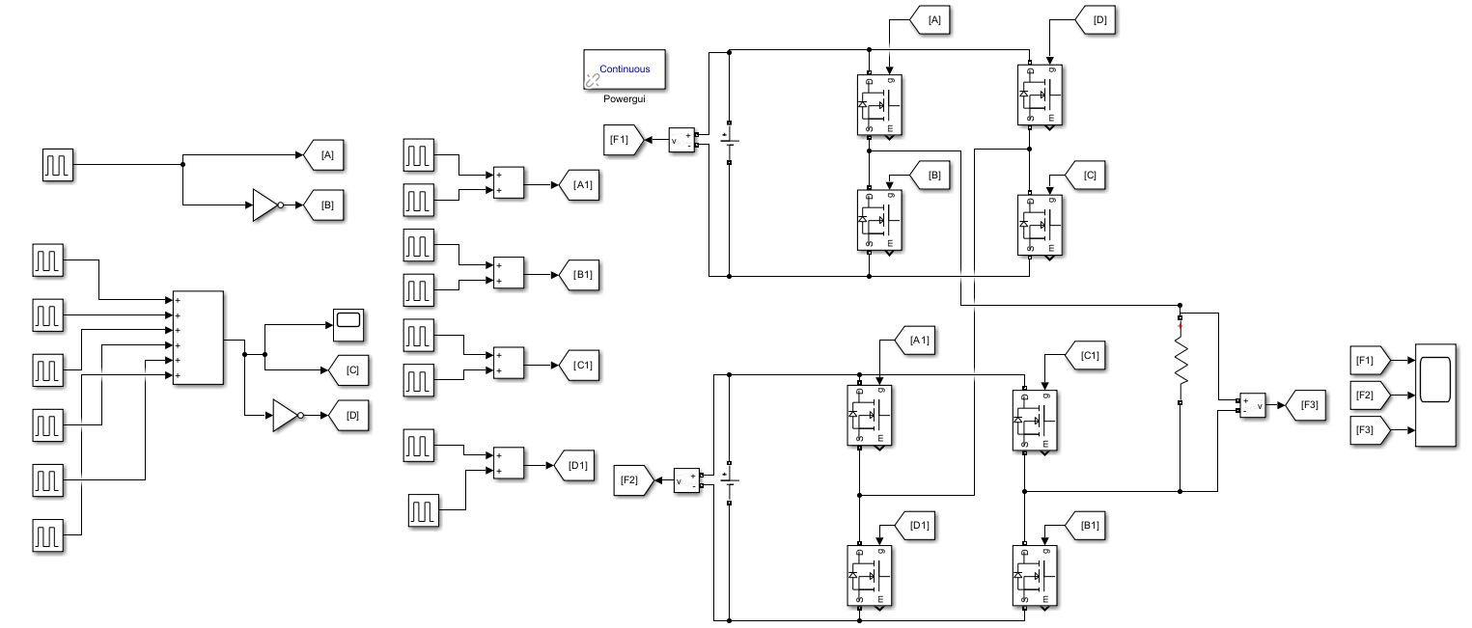

**Fig. Block Diagram of Multilevel Inverter**



**Fig. Characteristics of Multilevel Inverter**

**Matrix Converter**

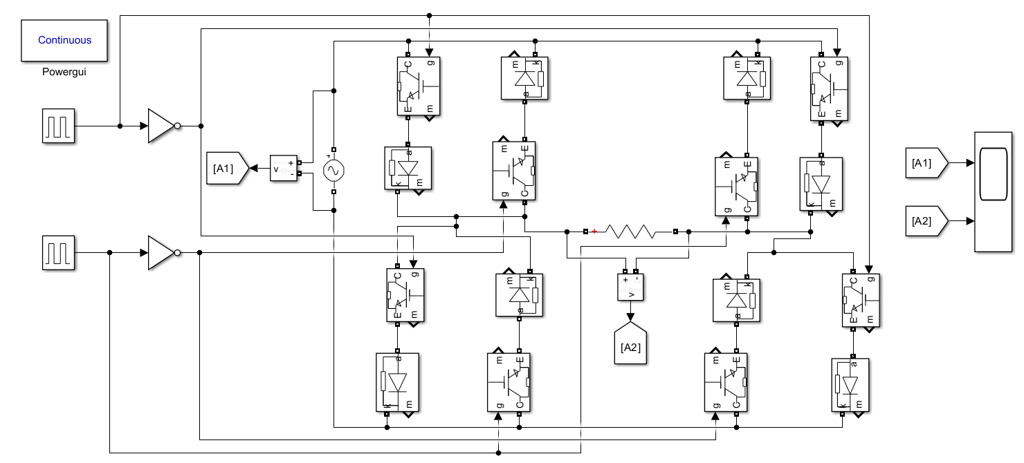

**Fig. Block Diagram of Matrix Converter**



**Fig. Characteristics of Matrix Converter**